**Daily Scrum or Standup Meeting**

Team name: Team 08

Scrum Master: Zion Steiner

Date: Nov 20

|  |  |  |  |
| --- | --- | --- | --- |
| **Team Member** | **What did you do since the last Scrum?** | **What do you plan to do before the next scrum?** | **What obstacles do you have?** |
| Hannah Howell | * Implemented a publish/archive button with functionality * Algorithms homework * Tech comm preparation | * Refactor where I can * Improve visual qualities | * Sick Husband still. He has the flu and pneumonia. Fun times. |
| Garrett Johnson | * Made the item QR code page. | * Make the QR code page pretty (or at least less ugly). | * Other homework |
| Zion Steiner | * Algorithms homework | * Start working on “users should be able to join an auction” task | * CS 5890 project that may or may not be finished |
| Tristan Thomas | * Reformatted auction info card for mobile | * Finish reformatting for mobile | * Tech Presentation * OS program to write |
| N/A |  |  |  |

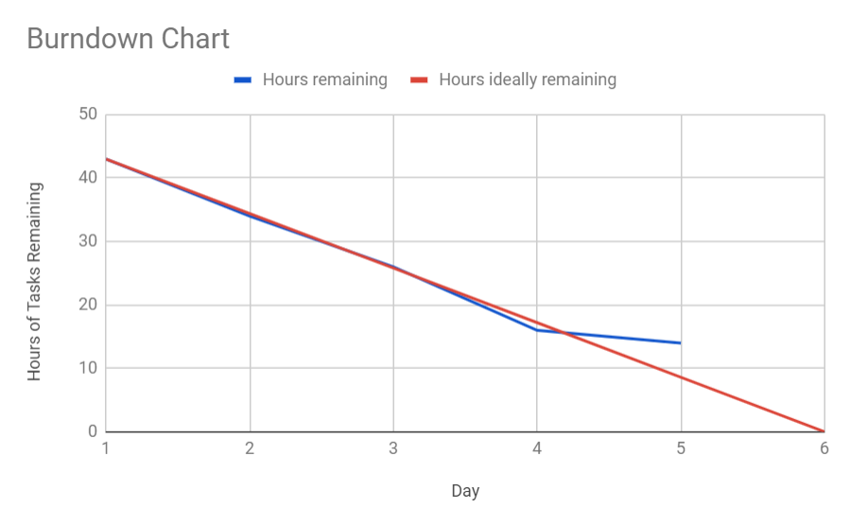

# Screenshot of your project board

